**AD110: USER INTERFACE DESIGN - Capstone Project 2**

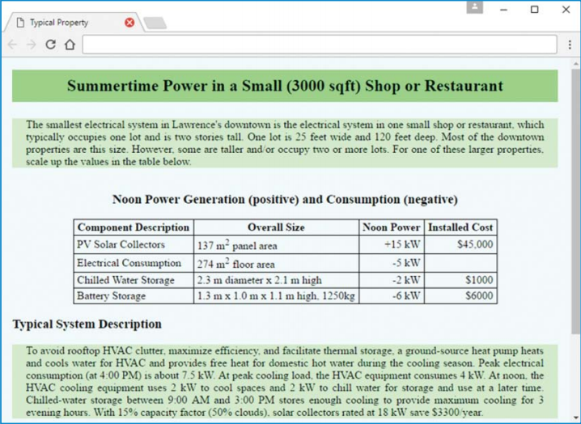

**A Downtown Store’s Electrical Generation and Consumption**

**Capstone Project Overview**

This course includes an extended example of iterative construction of a website. This website’s theme is a proposed electric-power “microgrid” for the core of a particular small city—Lawrence, Kansas. A microgrid is a small version of a large electrical power network. In normal operation, it provides valued electrical services to local users and the outside world. If disconnected from the outside world, it employs locally generated solar power and previously stored energy to continue providing critical electrical services to local users.

This ongoing case study generates 10 distinct web pages: Electric Power History, Lawrence Hydropower, Area Description, Microgrid Possibilities, Typical Property, Local Energy, Collector Performance, Electric Power Services, Downtown Properties, and Solar Shadowing. For the most part, each of these web pages is developed completely within the case study section at the end of just one chapter. But in some instances, a web page is iteratively enhanced over two or more chapters. For example, the Electric Power History and Lawrence Hydropower web pages are developed separately at the ends of Chapters 1 and 2, respectively, and then enhanced together at the end of Chapter 3. Also, the Area Description web page is developed at the end of Chapter 3, enhanced at the end of Chapter 7, and enhanced again at the end of Chapter 9.

**Capstone Project 2 Description:**

Complete Case-Study sections in Chapters 4 and 5.

**Chapter 4: (pp 155 - 160)**

Microgrid Possibilities in a Small City microgridPossibilities.html will illustrate local hypertext navigation.

**Chapter 5: (pp 203 - 206)**

A Downtown Store’s Electrical Generation and Consumption typicalProperty.html will illustrate use of HTML table elements

Submit your files to **Capstone** **Project Part 2 in Moodle**.

**FOR INSTRUCTOR USE ONLY**

**Grading Rubric**

*Grading accepts a start value of 100. Points will be deducted for failure to fully complete or meet the stated requirements. Grading: 90-100 = Represents work of superior quality (A); 80-89 = Represents work of good to very good quality (B); 70-79 = Represents adequate command of class content (C); 69 and below = Represents work that shows a need for development or improvement (F); 0 = Represents plagiarized work (F).*

**AD110: USER INTERFACE DESIGN (NCP-WEB)**

**Student:**

**Instructor:**

**Date:**

**Capstone Project 2**

|  |  |  |
| --- | --- | --- |
| **Description of requirements** | **Possible Points** | **Your Points** |
| Submitted HTML and CSS files to Moodle | **30** |  |
| Complete Chapter 4 Case study section | **35** |  |
| Complete Chapter 5 Case study section | **35** |  |
| **TOTAL** | **100** |  |

**YOUR SCORE**: ________

**Instructor Comments:**